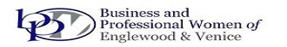
PEARLS OF WISDOM WORKSHOP
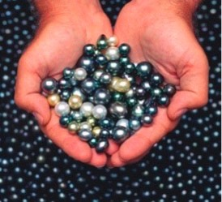
SPONSORSHIP FORM
“The Pearls of Wisdom Workshop” is an event scheduled for September 11, 2021 at
Plantation Golf and Country Club, 500 Rockley Blvd. Venice.
Yes, I am happy to sponsor the “Pearls of Wisdom Workshop”
___ $250 – PLATNIUM LEVEL: Promotion in program, on flier, newsletter, website and in
press release. Verbal promotion at the event. Includes admission for two guests.
___ $150 – GOLD LEVEL: Promotion in program and verbal promotion at the event.
Includes admission for one guest.
___ $75 – SILVER LEVEL: Promotion in program and verbal promotion at the event.
Company: ______________________________________________________________
Address: ______________________________________________________________
Phone: _____________________ Email: ____________________________________
Make checks payable to BPWEV and mail to PO Box 611, Englewood, FL 34295 or via website at bpwev.org. Call Esther with questions at 315-440-6814. Deadline 9/4/21

BPWEV is a 501(c)(3) Tax Deductible Non-profit Corporation, Florida Solicitation License #CH30762. A COPY OF THE OFFICIAL
REGISTRATION AND FINANCIAL INFORMATION MAY BE OBTAINED FROM THE DIVISION OF CONSUMER SERVICES BY CALLING
TOLL-FREE WITHIN THE STATE. REGISTRATION DOES NOT IMPLY ENDORSEMENT, APPROVAL, OR RECOMMENDATION
BY THE STATE. Division of Consumer Services may be reached at 1-800-HELP-FLA or www.FloridaConsumerHelp.com

