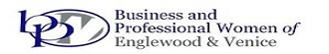
JEWELS OF BUSINESS
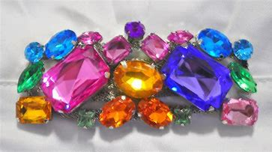
SPONSOR FORM
"Jewels of Business" is a professional development workshop being presented on
December 5, 2020 at Plantation Golf and Country Club, 500 Rockley Blvd., Venice
Yes, I am happy to sponsor the "Jewels of Business" workshop:
___ $200 - PLATNIUM LEVEL: Promotion in program, on flier, newsletter, website, and in press release. Verbal promotion at event. Includes two tickets to the event.
___ $125 - GOLD LEVEL: Promotion in program and verbal promotion at event. Includes one ticket to the event.
___ $75 - SILVER LEVEL: Promotion in program and verbal promotion at event.
Company: ________________________________________________________
Address: ________________________________________________________
Phone: _____________________ Email: _____________________________
Please make checks payable to BPWEV and mail to PO Box 611, Englewood, FL 34295. Deadline is
November 21. Questions? Call Esther at 315.440.6814. Thank you for your support.
All proceeds to benefit scholarship fund.
BPWEV is a 501(c)(3) Tax Deductible Non-profit Corporation, Florida Solicitation License #CH30762. A COPY OF THE OFFICIAL
REGISTRATION AND FINANCIAL INFORMATION MAY BE OBTAINED FROM THE DIVISION OF CONSUMER SERVICES BY CALLING
TOLL-FREE WITHIN THE STATE. REGISTRATION DOES NOT IMPLY ENDORSEMENT, APPROVAL, OR RECOMMENDATION
BY THE STATE. Division of Consumer Services may be reached at 1-800-HELP-FLA or www.FloridaConsumerHelp.com

