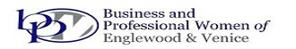
JEWELS OF BUSINESS
(An individual development program for women)
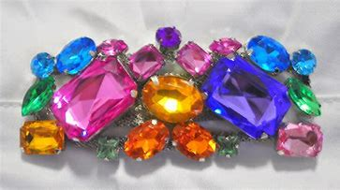
SATURDAY, DECEMBER 5, 2020
8:30 registration - Program 9am -3pm - includes breakfast and lunch
Location - Plantation Golf and Country Club, 500 Rockley Blvd. Venice
TICKETS: $30.00
Our guest speakers will address these interesting topics:
Safe Use of Technology - Mark Rizzo
How Do I Get it all Done? - Cyndi Fredricks
Personal Health - Bill Mechling
Spiritual Health - M. K. Mueller
Personal Challenges - Dr. Christopher Cortman
Cosmetic Options for Today's Women - Dr. Karen Helmick
Call Esther with questions and to reserve your spot - 315-440-6814 - or email estherbird2@aol.com
You may mail your check written to BPWEV to PO Box 611, Englewood, FL 34295.
Deadline 11/27. All proceeds benefit: BPWEV Scholarship Fund

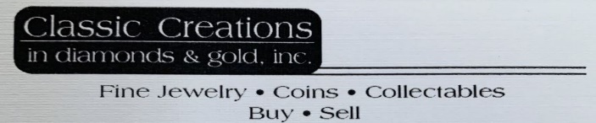
&
BPWEV is a 501(c)(3) Tax Deductible Non-profit Corporation, Florida Solicitation License #CH30762. A COPY OF THE OFFICIAL
REGISTRATION AND FINANCIAL INFORMATION MAY BE OBTAINED FROM THE DIVISION OF CONSUMER SERVICES BY CALLING
TOLL-FREE WITHIN THE STATE. REGISTRATION DOES NOT IMPLY ENDORSEMENT, APPROVAL, OR RECOMMENDATION
BY THE STATE. Division of Consumer Services may be reached at 1-800-HELP-FLA or www.FloridaConsumerHelp.com

